Chapter 5: Network Layer Control Plane

* Link cost changes:
  + Node detects local link cost change
  + Updating routing info, recalculates distance vector
  + If DV changes notify neighbors.
  + 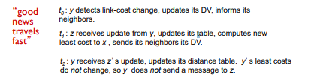
  + 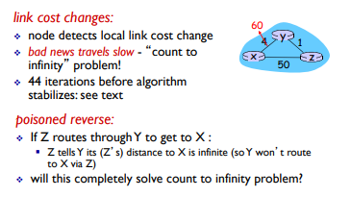
* Comparison of LS and DV algorithms
  + message complexity
    - LS: with n nodes, E links, O(nE) msgs sent
    - DV: exchange between neighbors only • convergence time varies
  + speed of convergence
    - LS: O(n2) algorithm requires O(nE) msgs •
      * may have oscillations
    - DV: convergence time varies •
      * may be routing loops •
      * count-to-infinity problem
  + Robustness
    - LS: •
      * node can advertise incorrect link cost •
      * each node computes only its own table
    - DV: •
      * DV node can advertise incorrect path cost •
      * each node’s table used by others •
      * error propagate thru network
* Making routing scalable
  + our routing study thus far - idealized
    - all routers identical
    - network “flat”
    - … not true in practice
  + scale: with billions of destinations:
    - can ’t store all destinations in routing tables!
    - routing table exchange would swamp links!
  + administrative autonomy
    - internet = network of networks
    - each network admin may want to control routing in its own network